How to configure DNS setup in Manipur DNS server – for existing record sets

Login to the DNS server 13.127.42.18
Go to the cd /etc/bind/
Then ls- la
You will get all the record sets
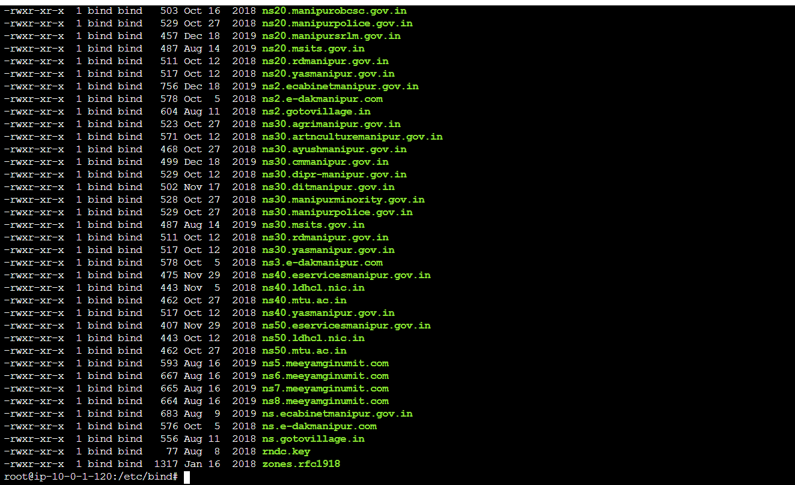
Select the record sets which you need to edit (or) search using ls | grep
Then follow these steps:
vi ns10.manipur.gov.in
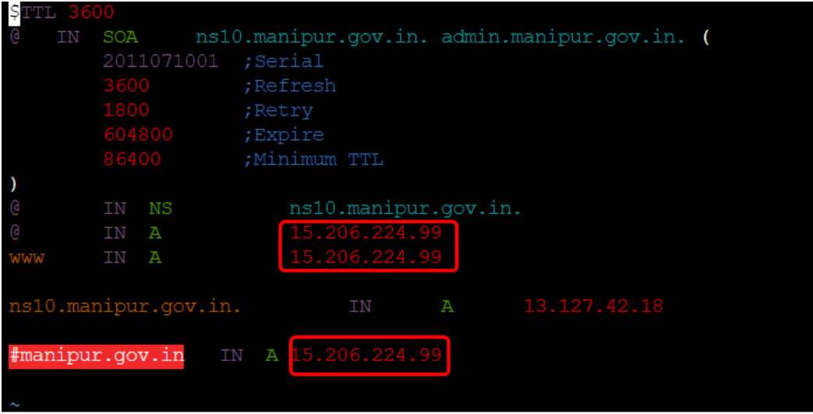
Then replace the IP with the new server IP which is being hosted and save
Do the same for all the record sets
Example : vi ns20.manipur.gov.in vi for.manipur.gov.in

